**Amazon EC2**

* EC2 is one of the most popular of AWS’ offering
* EC2 = Elastic Compute Cloud = Infrastructure as a Service

**EC2 sizing & configuration options**

* Operating System (OS): Linux, Windows or Mac OS
* How much compute power & cores (CPU)
* How much random-access memory (RAM)
* How much storage space:
  + Network-attached (EBS & EFS)
  + hardware (EC2 Instance Store)
* Network card: speed of the card, Public IP address
* Firewall rules: security group
* Bootstrap script (configure at first launch): EC2 User Data

**Creating our First Website in EC2**

* Once the EC2 instance is up and running, we can go ahead and create our first website.
* In order to host our website we have to install a webserver (ex. apache)
* What is apache?
  + It is a lightweight webserver, it is used to host the web application.
* In order the install apache web server we can take the help of package manager “yum”.

Step 1: Update the operating system

sudo yum update -y

Step 2: Install apache webserver

sudo yum install httpd -y

Step 3: Start the webserver.

sudo systemctl start httpd

Step 4: Check the status of the webserver by running the below command, it should be running

sudo systemctl status httpd

* once apache webserver installed, you can configure your website, to do so you have to follow the below steps.

Step 5: Go to the /var/www/html location by running below command.

cd /var/www/html

Step 6: Create index.html page by running below command

sudo vi index.html

press “i” button from key board to go on insert mode

put some content like below

<h1>Hello World</h1>

The save the file by pressing “:” button and “x” button

Then reload the page in the browser.

* then in order to access your website copy the public ip of EC2 instance from AWS portal and put is in the browser and search.

**EC2 User Data**

* It is possible to bootstrap our instances using an EC2 User data script.
* bootstrapping means launching commands when a machine starts
* That script is only run once at the instance first start
* EC2 user data is used to automate boot tasks such as:
* Installing updates
* Installing software
* Downloading common files from the internet
* Anything you can think of
* The EC2 User Data Script runs with the root user

**EC2 Instance Types - Overview**

* You can use different types of EC2 instances that are optimised for different use cases (https://aws.amazon.com/ec2/instance-types/)
* AWS has the following naming convention:

m5.2xlarge

m: instance class

5: generation (AWS improves them over time)

2xlarge: size within the instance class

**EC2 Instance Types – General Purpose**

* Great for a diversity of workloads such as web servers or code repositories
* Balance between:
  + Compute
  + Memory
  + Networking
* In the course, we will be using the t2.micro which is a General Purpose EC2 instance

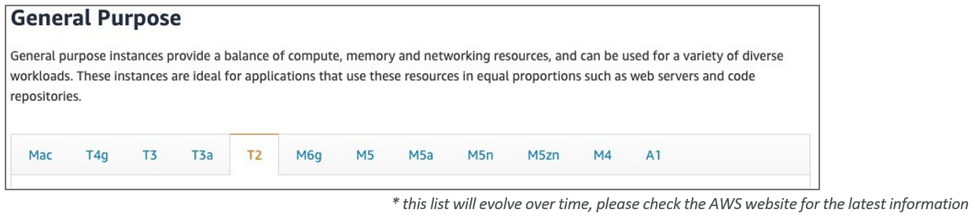

**EC2 Instance Types – Compute Optimized**

* Great for compute-intensive tasks that require high performance processors:
  + Batch processing workloads
  + Media transcoding
  + High performance web servers
  + High performance computing (HPC)
  + Scientific modeling & machine learning
  + Dedicated gaming servers

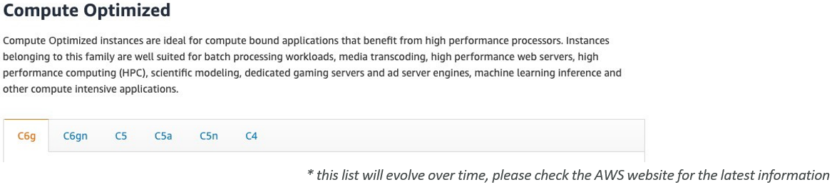

**EC2 Instance Types – Memory Optimized**

* Fast performance for workloads that process large data sets in memory
* Use cases:
  + High performance, relational/non-relational databases
  + Distributed web scale cache stores
  + In-memory databases optimized for BI (business intelligence)
  + Applications performing real-time processing of big unstructured data

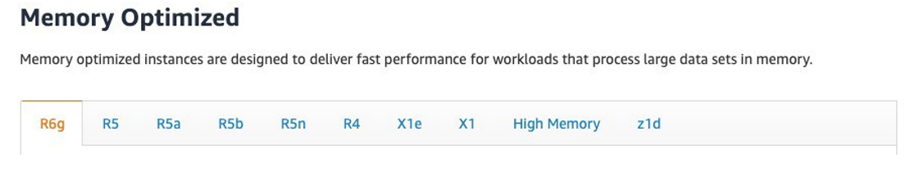

**EC2 Instance Types – Storage Optimized**

* Great for storage-intensive tasks that require high, sequential read and write access to large data sets on local storage
* Use cases:
  + High frequency online transaction processing (OLTP) systems
  + Relational & NoSQL databases
  + Cache for in-memory databases (for example, Redis)
  + Data warehousing applications
  + Distributed file systems

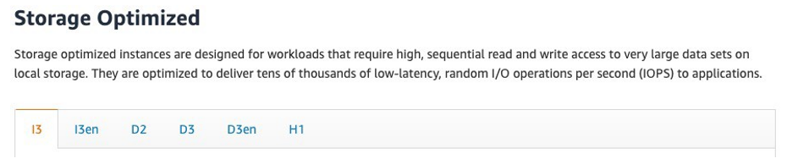

**EC2 Instance Types: example**

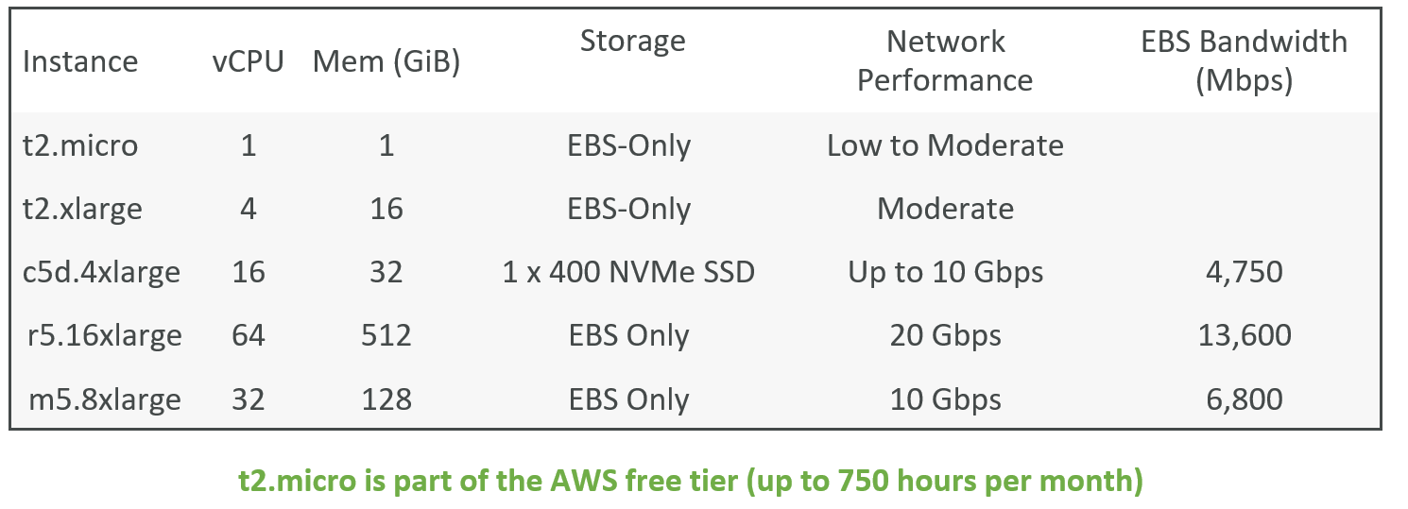

**Resizing the EC2 Instance**

* We can change the CPU, Memory (RAM) capacity of our EC2 instance after creation.
* In order to do so we have to first stop our EC2 instance and modify the CPU and memory capacity as per our requirement and start the instance.

**Amazon Machine Image (AMI)**

* Amazon Machine Image (AMI) is the master image from which new EC2 instances can be launched.
* It is also called backup of EC2 instance, backup is used to restore in case of failure
* Let’s understand with an example:

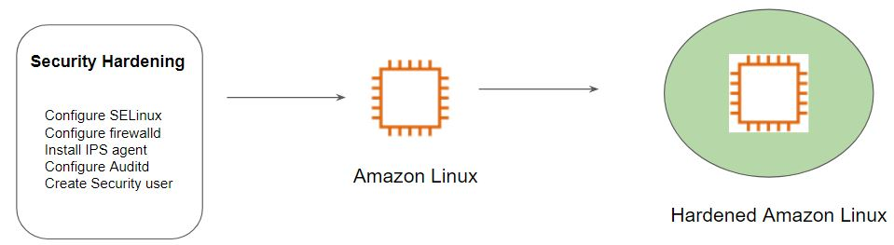

The architecture of Hardened AMI Deployment:

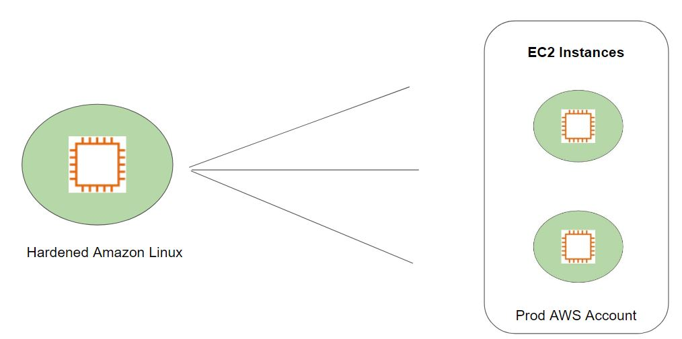

**How to create custom image**

* Launch EC2 instance from existing AMI.
* Install and configure the software as per the requirement.
* create image of the instance.
* you can terminate the instance once image is ready.

**How to copy AMI from one region to another.**

* Select the AMI you want to copy.
* Click on the action drop down list and click on copy AMI
* Give a Name of the AMI (as per your choice)
* Select the region you want to copy your AMI to.
* Click on copy AMI button.

**AMI Permission**

* By default, whatever the AMI we create it is actually a private AMI, means it can be accessible in our account only.
* But we have the option to share with other AWS action by modifying the permission.
* We can even make it public so that it can be available to all the AWS account

***Note: while sharing AMI make sure you don’t have any sensitive data.***

**Placement Groups**

* Point 1: Placement group are recommended for applications that require low latency, high network throughput.
* Point 2: Placement groups can also be used to influence placement of a group of EC2 instances.
* Below diagram gives an analogy related to the first pointer of placement group where high throughput is required.



* Point 2 can be better understood if you have worked with virtualization. In the below diagram, we see that there are multiple virtual machines running on a single hardware. The same can be the scenario where there are multiple EC2 instances running on same hardware.

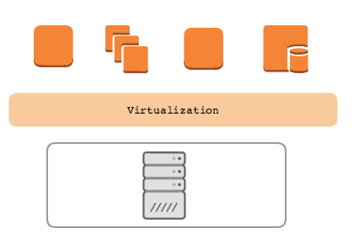

* When the VM architecture is in place, there is always risk specifically when two servers of the same cluster are running on the same underlying host. If the underlying server goes down then all VM running on top of it are down.

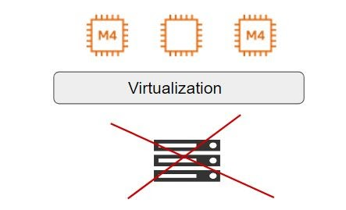

* With Point 2, we can explicitly place two EC2 instances in a different hardware even when it is running in the same Availability Zone.

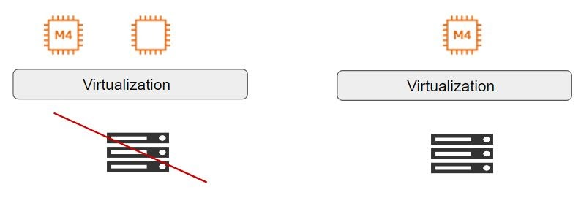

**Types of Placement Groups:**

There are three types of placement groups available:

|  |  |  |
| --- | --- | --- |
| **Sr No** | **Type** | **Description** |
| 1 | Cluster | Packs instances close to each other in an Availability Zone. |
| 2 | Partition | Spreads instances in logical partition such that group of instances in one partition do not share underlying hardware. |
| 3 | Spread | Strictly places group of instances across distinct hardware to reduce failures. |

**Cluster Placement Group**

* Logical grouping of instances within a single Availability Zone.
* Intended for applications that require low network latency and high network throughput.

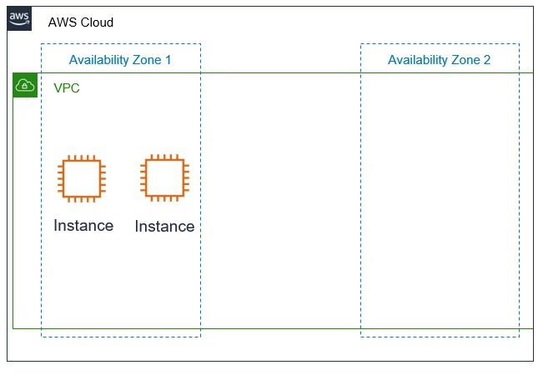

**Partition Placement Group**

* AWS ensures that each partition within a placement group has its own set of racks.
* In the below diagram, there are 3 partitions, and each partition has multiple EC2 instances.
* Each of these partitions resides in a different rack inside the Datacenter.

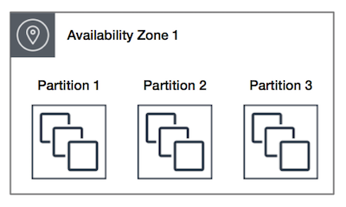

**Spread Placement Group**

* A spread placement group is a group of instances that are each placed on distinct racks, with each rack having its own network and power source.
* In the following diagram, there are 7 EC2 instances and each instance is in a separate rack.

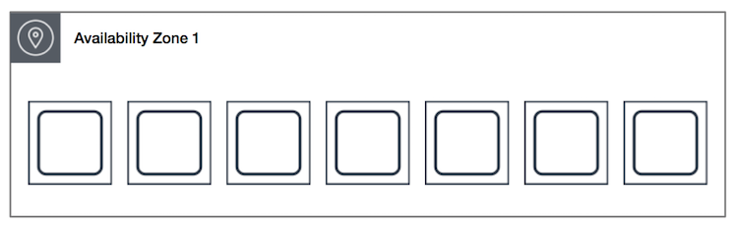

**Important Pointers - Cluster Placement Group**

* A cluster placement group can't span multiple Availability Zones.
* Only specific types of EC2 instances can be launched.

**Launch Template**

* When you launch an EC2 instance, there are various configurations that needs to be set.
* Some of the common configuration includes:
  + AMI ID
  + Instance Type
  + Security Group
  + Key Pair
  + Storage
  + IAM Role
  + VPC
* Everytime when you intend to launch instance, going through process is time consuming,
* Launch templates enable you to store launch parameters so that you do not have to specify them every time you launch an instance.

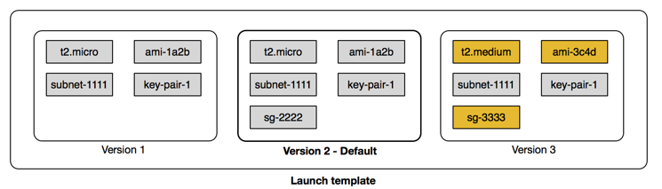

**Introduction to Security Groups**

Security Groups are the fundamental of network security in AWS

They control how traffic is allowed into or out of our EC2 Instances.

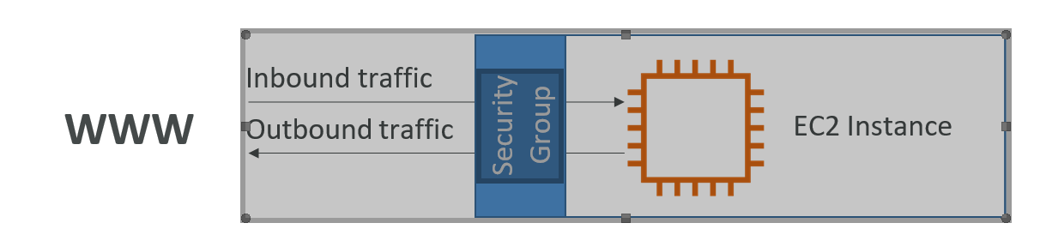

* Security groups only contain allow rules
* Security groups rules can reference by IP or by security group

**Security Groups Deeper Dive**

* Security groups are acting as a “firewall” on EC2 instances
* They regulate:
* Access to Ports
* Authorised IP ranges – IPv4 and IPv6
* Control of inbound network (from other to the instance)
* Control of outbound network (from the instance to other)

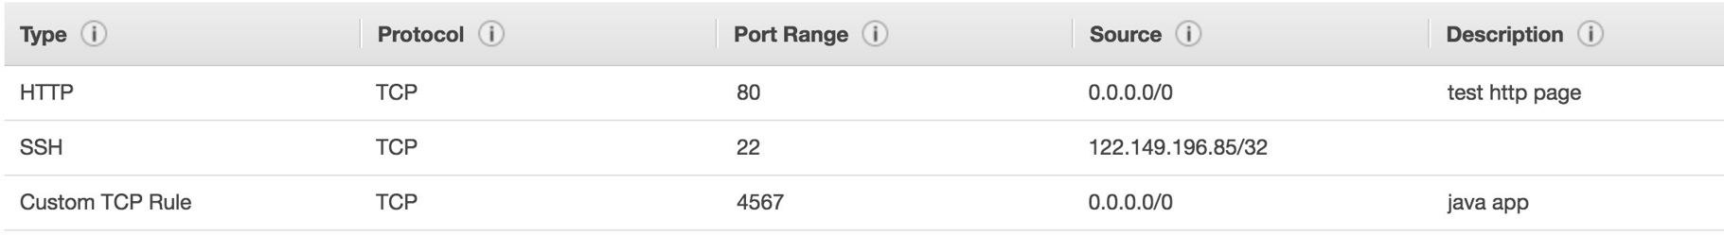

**EC2 Instances Purchasing Options**

* On-Demand Instances: short workload, predictable pricing
* Reserved: (MINIMUM 1 year)
  + Reserved Instances: long workloads
  + Convertible Reserved Instances: long workloads with flexible instances
  + Scheduled Reserved Instances: example – every Thursday between 3 and 6 pm
* Spot Instances: short workloads, cheap, can lose instances (less reliable)
* Dedicated Hosts: book an entire physical server, control instance placement
* Dedicated Instances: no other customers will share your hardware

**EC2 On Demand**

* Pay for what you use:
  + Linux or Windows - billing per second, after the first minute
  + All other operating systems - billing per hour
* Has the highest cost but no upfront payment
* No long-term commitment
* Recommended for short-term and un-interrupted workloads, where you can't predict how the application will behave

**EC2 Reserved Instances**

* Up to 72% discount compared to On-demand
* Reservation period: 1 year = + discount | 3 years = +++ discount
* Purchasing options: no upfront | partial upfront = + | All upfront = ++ discount
* Reserve a specific instance type
* Recommended for steady-state usage applications (think database)
* Convertible Reserved Instance
* can change the EC2 instance type
* Up to 66% discount
* Scheduled Reserved Instances
* launch within time window you reserve
* When you require a fraction of day / week / month
* Commitment for 1 year only

**EC2 Spot Instances**

* Can get a discount of up to 90% compared to On-demand
* Instances that you can “lose” at any point of time if your max price is less than the current spot price
* The MOST cost-efficient instances in AWS
* Useful for workloads that are resilient to failure
  + Batch jobs
  + Data analysis
  + Image processing
  + Any distributed workloads
  + Workloads with a flexible start and end time
* Not suitable for critical jobs or databases

**EC2 Dedicated Hosts**

* An Amazon EC2 Dedicated Host is a physical server with EC2 instance capacity fully dedicated to your use. Dedicated Hosts can help you address compliance requirements and reduce costs by allowing you to use your existing server-bound software licenses.
* Allocated for your account for a 3-year period reservation
* More expensive
* Useful for software that have complicated licensing model (BYOL – Bring Your Own License)
* Or for companies that have strong regulatory or compliance needs